**IBM IoT Assignment – 4**

1. **Write a code and connections in wokwi for the ultrasonic sensor. Whenever the distance is less than 100cms send an “Alert” to IBM cloud and display in the device recent events**

**Python code:**

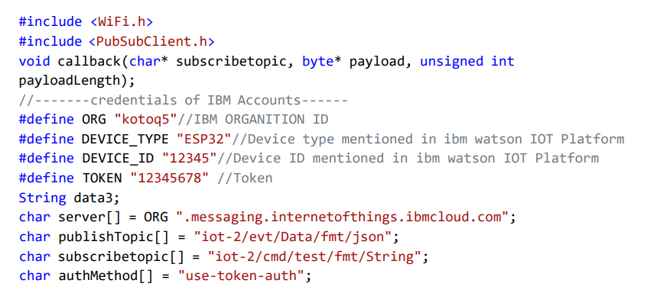

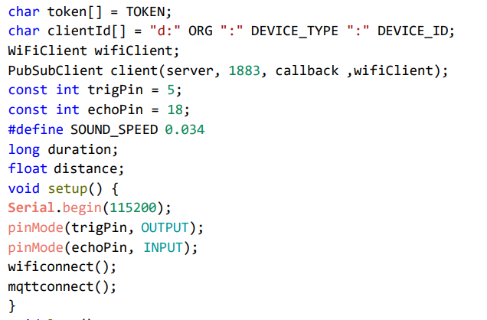

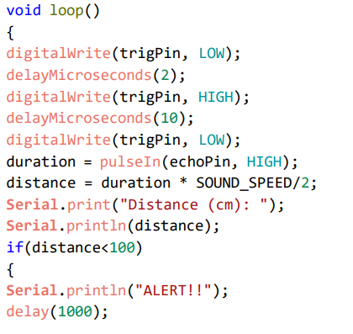

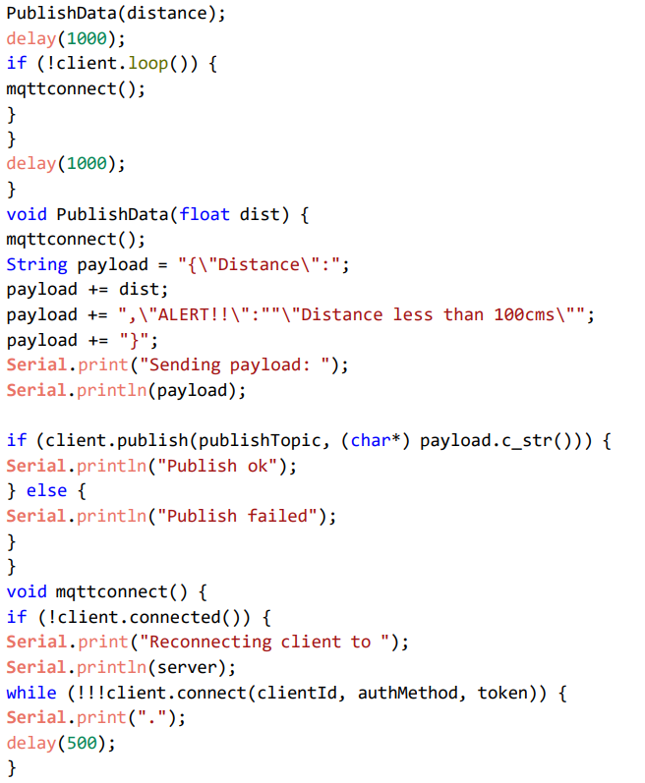

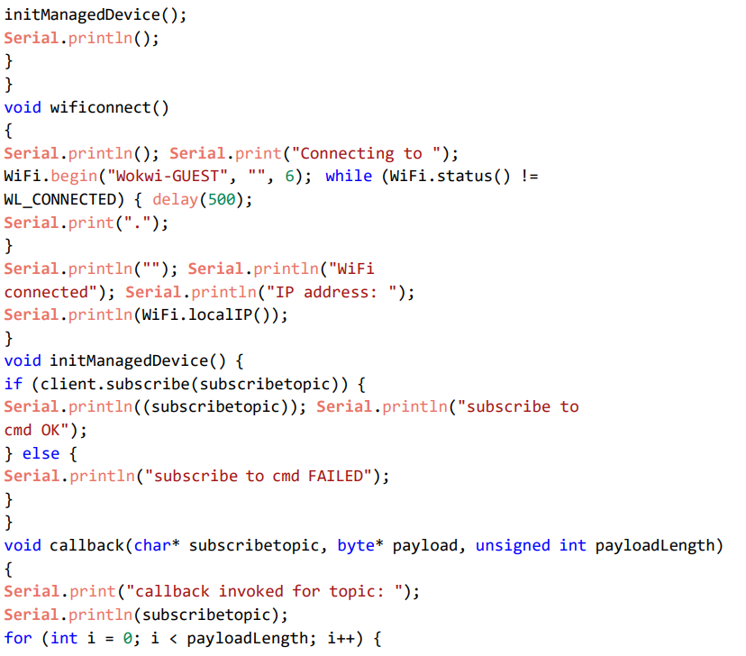

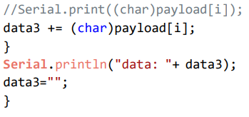

**Diagram.json**

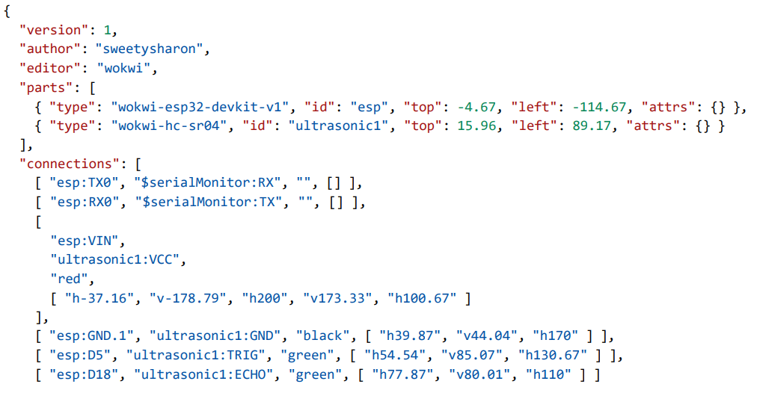

**Wokwi Simulation link:**

[**https://wokwi.com/projects/348473774641775187**](https://wokwi.com/projects/348473774641775187)

**Circuit Diagram:**

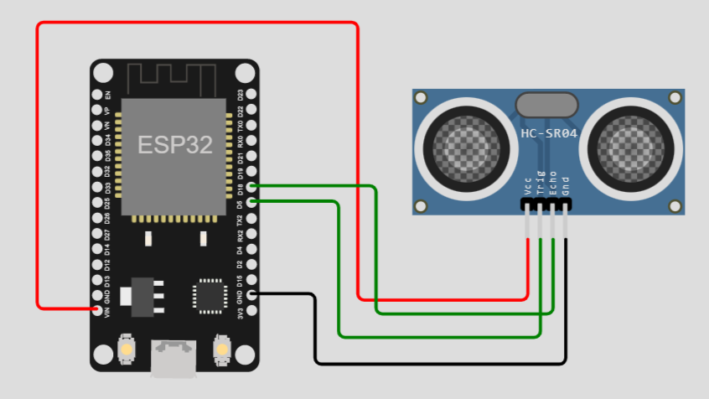

**Output:**

**Wokwi output:**

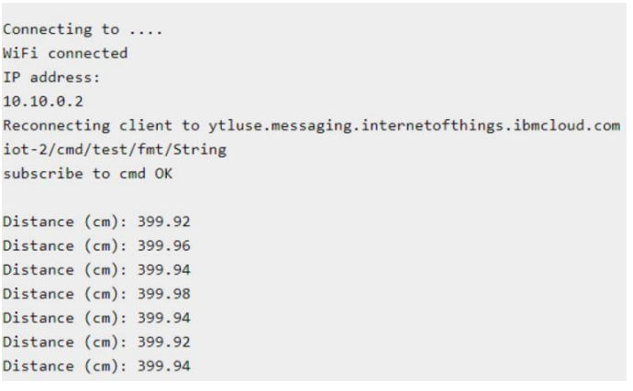

**IBM Cloud output:**

